Creating a clothing brand with sustainable values

Target Publication: HuffPost UK, Life section, under Money & Work

Creating a clothing brand has always been a dream of mine. During an appointment at my favourite hairdresser in London, she explained to me how she was doing exactly that. I have been thinking about how the market is so oversaturated now. My hairdresser Lau explained how her brand Concept is made sustainable, which is evolving and getting more and more appreciated in society today.

As she cut my bangs, she explained to me what print on demand is, a smart solution to overproduction and waste. “So as soon as we accept an order, we notice the manufactory and they then produce it for the particular order”, she said with enthusiasm and looked at me in the mirror. “Do you want any styling today?” Lau she said, looking up at me again. “Yes, that would be amazing”, I replied with a smile. She is an amazing hairdresser, through our conversation I also learned that she has an MA degree in Art from the University of Brighton, and this has inspired the design of her clothing brand.

Most of her design is drawn or painted, then she re-do them and send then sketches to the manufactory Teemill, which is sustainable and eco-friendly.

With my fresh haircut and styling, I did some research on the manufactory which is a renewable energy powered factory. Meaning the electricity in the factory comes from renewable energy sources, like for example solar panels. Teemill also make their products from natural materials like organic cotton. The products from this factory are also made to be sent back, to be remade when necessary. Plastic free packaging is also one of the benefits, to products made from Teemill.

Talking to Lau made me understand the value of print on demand, especially for businesses in the start-up phase. As Lau said: “It gave me the confidence to start the brand, as it diminished the risk of production waste and unnecessary money loss for production”, she said.

Since I always have been curious on how to start a clothing brand from scratch, I asked her more tips on this and she gave me an interesting answer:

“To save money on the photos for the website and social media, I use AI models. This saves a lot of time and money, but my goal is to do real photo shoots in the future”, she told me. I was shocked, scrolling through Concept Instagram page now knowing that the models posing, was not actually real.

“The main meaning behind Concept is spreading awareness around sustainability, especially for the younger generation, as they are the future”, she said.

“I have always been passionate about fashion and wanting to create my own brand but having an important and bigger purpose behind it, is extra fulfilling”, Lau told me, when I visited her at the salon, so she could give me a sneak peek into the newest products from Concept.

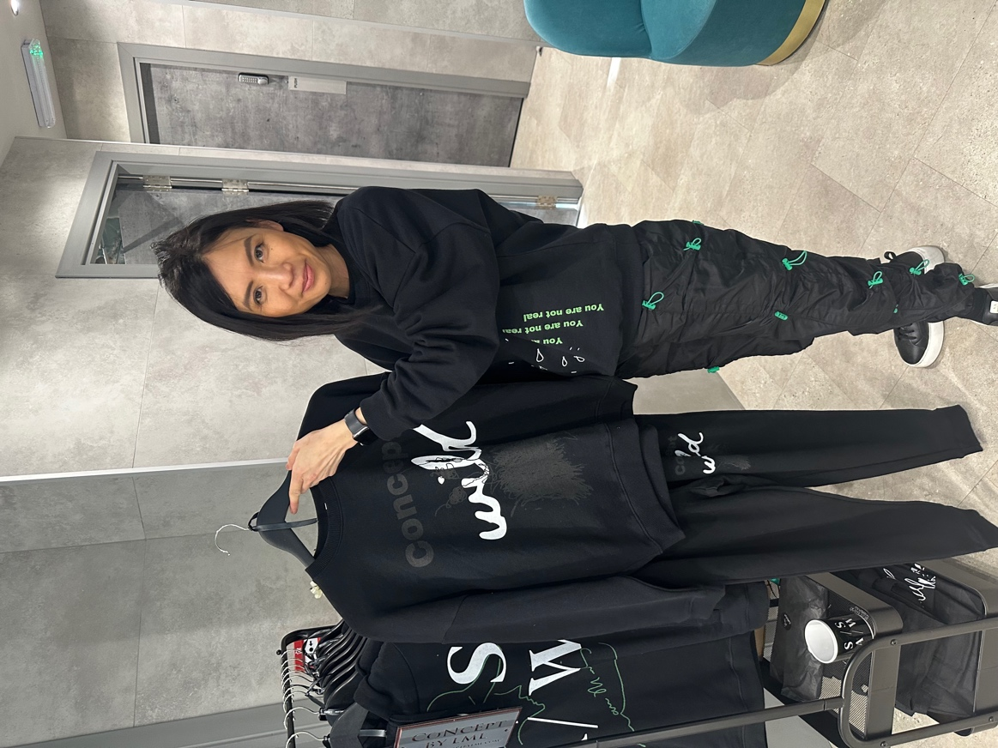
Lau proudly showing some of the clothes from her brand Concept.

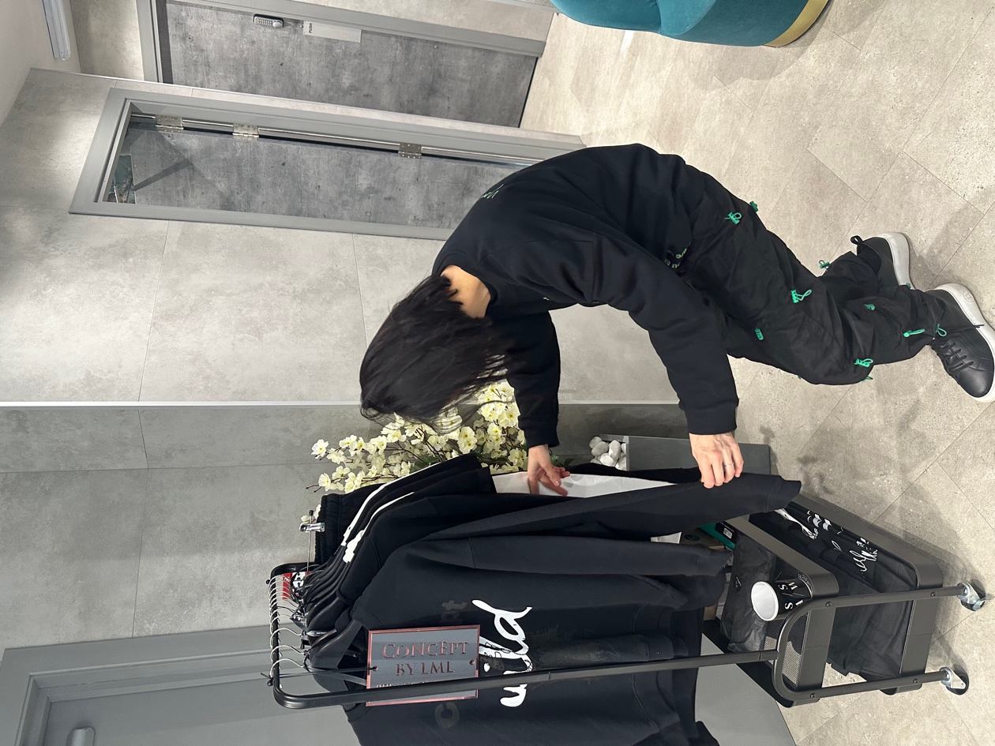
Photo credits: Mathilde Albertsen

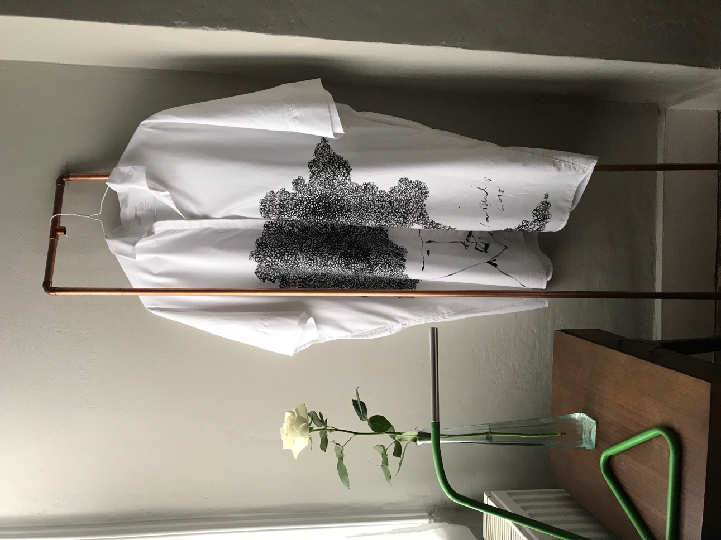

How it started, drawings directly on the clothes.
Photo credits: Lau Munlen

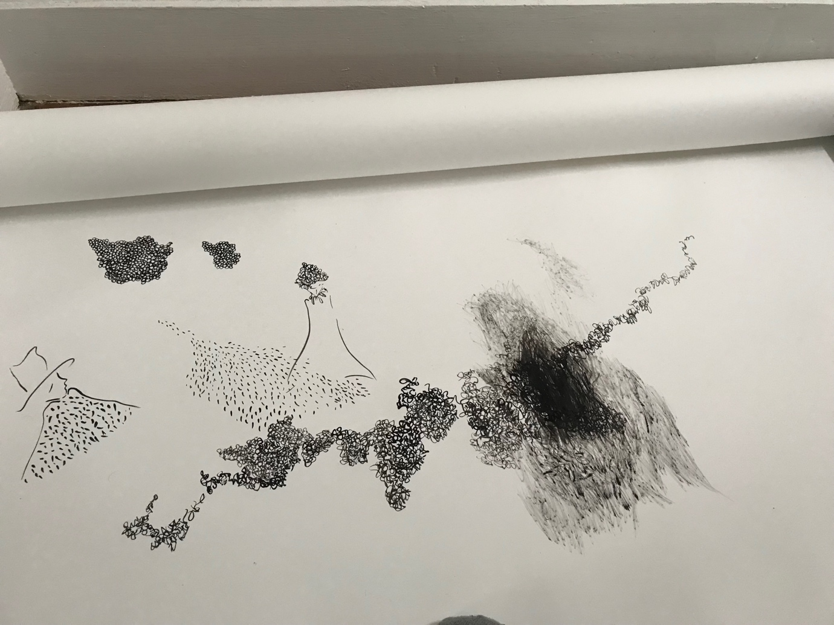
Pictures from Lau’s sketches.
Photo credits: Lau Munlen

For more about Concept, follow the link below:

Website: https://conceptbylml.com/?fbclid=PAAaYiJMn-H0qbWFreHIHnDu1YZhrlCQ_K7IoeQTVjqRivmdD0fiaqV7i-4m8_aem_AZX9ZI4TPV9voo0vYVQnSGpa5qoGHhWzXheazvtdGC450BglVlfZiPPQwZ0ad66Xgxk

